AGREE WITH YOUR HEART
(AL CORAZON DALE LA RAZON)
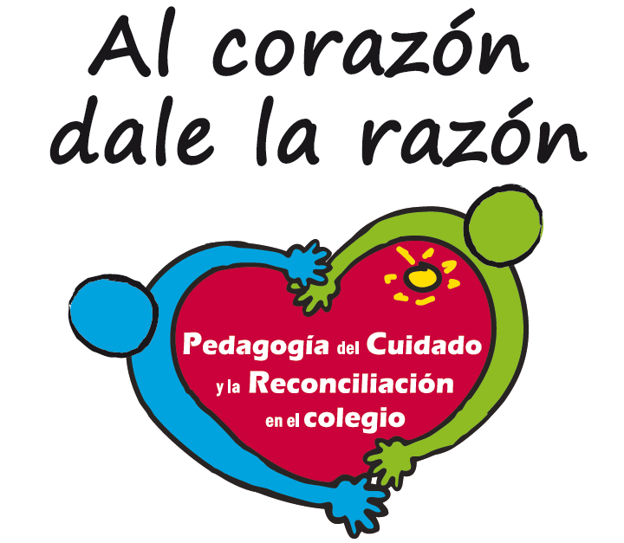
INTERNATIONAL PILOT PROJECT OF CARE AND RECONCILIATION PEDAGOGY

Presented to:
GOLDIN INSTITUTE

Bogota D.C. July 2013
Our awards:

CONTENTS
- INTRODUCTION
- FORGIVENESS AND RECONCILIATION SCHOOLS AT USME-BOGOTA.
  - Background: Selection and bounding process of the public schools
  - Characterization of Usme and the schools
  - The process ESPERE at Usme
  - ESPERE coverage
  - Results from the process which are visible through the net
  - Analysis and projections

- NETWORK FOR RECONCILIATION: platform online
  - Stages and growth: progress on the network January 2013 to June 2013.
  - Network analysis
  - How do we talk through the Net about Forgiveness and Reconciliation? Impact in schools which is visible through the Net.
  - Analysis and projections

- INTRODUCTION

The project Care and Reconciliation Pedagogy (hereinafter referred to as PCR) began its activities at schools in October 2011. First, the school Padre Damian was visited in Arequipa, Peru and later on Loyola school in November in Dominican Republic, as well as Nuestra Señora de la Consolata School in Mendoza, Argentina. In January 2012, the first visit to Institute Mater was made in Monterrey, Mexico. As it is an international pilot project, the initial intervention design, has been enriched throughout experience. The learning processes with international schools have encouraged the activities planned which are being developed at three schools in Bogota, where the pilot started in January 2013.
The following report shows the activities, the observed learning processes and results between January and July 2013, in two dimensions: the training in forgiveness and reconciliation with teachers and the development of the network.
The main purpose of PCR is to transform the quality of relations given in schools, to reinforce the coexistence and to improve the quality of education. One of the main hypothesis in which the intervention design lies, is that in order to transform the relations in schools, it is necessary to offer people who are part of that community, the opportunity to go through a forgiveness and reconciliation experience. Based on the PCR hypothesis, The ESPERE, contribute to that participants learn how to transform hate towards others, resentment and revenge desire provoked by aggressions, into seeds of coexistence and progress.
The testimonies which are analyzed throughout this report, confirm as preliminary conclusion that ESPERE is a suitable platform to launch a process of institutional change because those contribute to a new perspective about human relations. As teachers claim: “With ESPERE: “people learn how to put in someone else’s shoes” and “they can also see things in a new light” referring to a new facet about the inherent conflicts to all interpersonal relationships.
A second hypothesis, in which the pilot lies, claims that an intervention in schools should start by the teacher and from there it should project towards a change on institutionalism elements, such as the school norm or the participation schemes. That is why the pilot contemplates on its first phase as starting point ESPERE for all teachers and then the collective exercise “Looking in the mirror”. The observations made in international schools through the network, as well as the recovered testimonies from the talks with teachers in Bogotá, allow to confirm that people acquire “new glasses” throughout which they can analyze the results from the surveys and the interviews done with the five mirrors, from the view of Care.
With these new glasses they can also propose changes to the structure of the school, where they will see authoritarian and violent elements. In teachers’ words, the contributions of ESPERE, on a preliminary intervention phase is suitable while “change comes first from the inside” and then I can project it to my students”. This change of perspective is expressing itself in some schools as the formulation of “Care commandments” that tend to replace the current norm. At Loyola and Damian schools for example, this new code of interpersonal relations has been subscribed, which is a key to “coexistence agreements”. During April, at Nuestra Señora de la Consolata School, students and teachers participated in sessions to look over the current norm, and adjust it to the concepts and practice of restored justice. This way it is advisable to check schools’ structures, based until now on a norm as only solution to the conflict through suspension or the social exclusion of the transgressor.
On the other hand, the following report sheds light on the progress of the network called “Network for Reconciliation”. From the perspective of the pilot design, dialogues are the main strategy to facilitate that each educational community can talk about the topics that require to be addressed to approach to coherence between the school’s ideal model and the daily practice. As shown in the documents from the project, dialogues seek:
“To generate convergence between the school described in the documents and the day to day school, that is shown on bulletin boards, arrangement and classification of the areas, norms about students’ haircuts and color, lines in the cafeterias etc.
This way, dialogues allow to communicate and to create a new reality about the interpretations that are building up individuals from Care Pedagogy. Through dialogues with others, people are transforming and creating new realities. The Network was developed from these principles which we have called: “meaning construction”. Therefore the way it has been used from the Foundation to be “the dialogue’s channel or instrument” comes to give analysis elements about the previous hypothesis.
The second phase of this report shows the development that the network has had between January and July 2013. The most relevant element from that process is precisely related to the way teachers from those seven schools have started talking among them, suggesting topics of their own interest around the PCR and sharing experiences with colleagues or students from the new perspective of Care and Reconciliation Pedagogy. The tenor of the current conversations on the Network describes a collective learning process, a genuine interest from participants when questioning themselves about their practice and learning from others, a willingness to be touched by a colleague’s experience and avoid only answers or disqualifications before dilemmas or posed problems.
- FORGIVENESS AND RECONCILIATION SCHOOLS AT USME-BOGOTA:

  - Background: Selection and bounding process of the official schools
The Pilot of Care and Reconciliation project covers five countries and in four of these, the participating schools are private and religious. In order to get more information for the project from various contexts, the Foundation decided that bounding schools in Colombia were public and were also working with populations from marginal contexts. For such purpose, there was a first attempt to work in Sumapaz and lately, before the difficulties that the rural context presented, during the second semester 2012 the “Direccion Local de Educación” (DILE) in Usme was contacted. In accordance to this organization, more than 70 principals from public and private schools were invited and finally three of them were reached. IED Tenerife Granada Sur, IED Virrey Jose Solis and IED Rural school at Usme alto, the first two urban and the third rural. An aspect that is worth noting as common characteristic from the three schools is that their respective principals (two men and one woman) had previous experience with pedagogical innovations which are focused on reinforcing coexistence. This facilitated hugely the progress the proposal had to begin from the first month in 2013 with ESPERE for teachers.
In November 2012, there was a short meeting-workshop with teachers to start to go in depth with the basic elements from the proposal and its methodology. In that context they were invited to go through the experience of ESPERE, letting them participate freely. From the three schools, more than fifty teachers showed interest, because of which a preliminary group was programmed to go through ESPERE in January 2013, which also became the milestone that would start up the Pilot program in Bogota.

  - Characterization of Usme and the schools
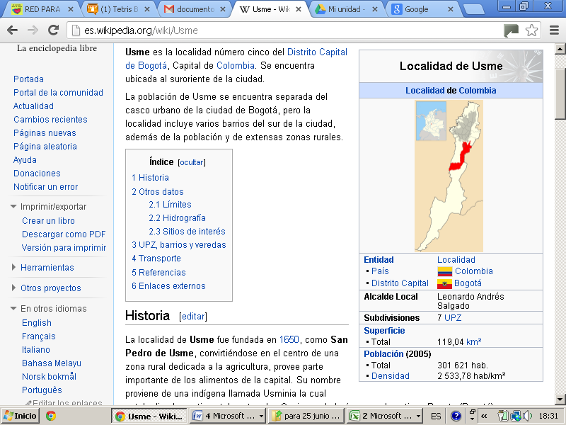
Locality of Usme
Usme is the 5th locality from Bogota city (Capital of Colombia) located on the south-east side in Bogota. In the urban area, the locality is divided into three neighborhoods and the rural area is divided into 15 rural districts. Usme is the 2nd locality in Bogota, after Sumapaz, with more rural areas (84%). Its inhabitants belong to socioeconomic status 1 (low low) and 2 (low).
In the 80’s Usme begins to experience closely the problems of the nation because of the armed conflict and becomes the fourth locality in Bogota with more displaced people coming from different parts of the country (Boyaca Santaderes). This situation determines to a large extent that the locality is characterized by complex problems such as:
- Displacement: The majority of the families are headed by women who have lost in different and violent ways their husbands, parents, siblings, children and partners.
- Domestic violence: The locality of Usme has shown high levels in domestic violence, child and sexual abuse, which have increased in the last years.
- Suicides: The locality of Usme is recorded on this topic as a critique, since it almost doubles the general results in Bogota, in terms of suicide.
Bringing the Care and Reconciliation Pedagogy into this socioeconomic context, implies particular challenges. A deep and paused process has been necessary to get to know well the educational environment and the way in which conflicts in the area affect relations in schools.
Schools bound to the Pilot Project:
From December 2012 the following schools are bound to the International Pilot project: Virrey Jose Solis, Tenerife Granada Sur and Rural Usme Alto. The basic details of each school as school population, teachers, calendars and school days, are shown on tables 1 and 3. For being in the same area, the schools share marginal situations and unstable economical conditions. When referring to the schools in the urban area, problems related to marginal growth areas, such as insecurity, drug use, dysfunctional families among other elements that principals identified as relevant. The school, as institution, has promoting and protecting roles for the transformation of such life conditions.
The urban schools have appropriate but not enough resources, for the development of pedagogical activities such as classrooms for meetings and projection teams. The Rural school has five branches (physical area) which do not have appropriate infrastructure.
Table 1: Basic Information School Virrey
IED VIRREY JOSE SOLIS
Name | IED VIRREY JOSE SOLIS
Principal | BETSY TURGA
Structure | Preschool , primary,high-school, (12 grades)
Location | Urban Area, Locality Usme, Bogotá Colombia,
Total Directing Board: | 1 Principal  1 Academic Coordinator in the mornings  2 Coordinators in the afternoons
Total Teachers: | 52 teachers
Motivator team: | 16 teachers y directive teachers
Total Students: | 1500 Students
School Days | Monday to Friday: School days Public Schools  Preschool Morning: 7:00 AM – 11:00 AM.  Primary Morning: 6:15 AM – 11:30 AM  High-school Morning: 6:15 AM – 12: 15 PM  Preschool Afternoon: 1:00 PM – 5:00 PM.  Primary Afternoon: 6:15 AM – 11:30 AM  High-school Afternoon: 6:15 AM – 12: 15 PM
Calendar | School Calendar of 40 weeks, from January 28th to November 28th. There are three breaks: Easter, 2 weeks in June-July, 1 week in October.
Basic Structure per subject area | 1 Principal  One academic coordinator in the morning and one in the afternoon  One School Counselor in the morning and one in the afternoon  One coordinator of school community life in the afternoon.  Preschool, Primary, High-school  Maintenance, security and cafeteria.

Table 2. Basic Information Tenerife School
IED TENERIFE GRANADA SUR
Name: | IED TENERIFE GRANADA SUR
Principal | Julián Prieto
Structure: | Preschool, Primary, High-school. (12 grades)
Location: | Urban area, Locality Usme, Bogotá Colombia,
Total Directing Board: | 1 Principal  1 Coordinator in the mornings  1 Coordinator in the afternoons
Total Teachers: | 62 Teachers
Motivation Team: | 13 docentes y directivos docentes
Total Students: | 1590 Students
School Days | Same school days as public schools
Calendar | School Calendar of 40 weeks, from January 28th to November 28th. There are three breaks: Easter, 2 weeks in june-july, 1 week in October.
Basic Structure per subject area | 1 Principal  1 Academic Coordiantor  1 School Counselor  Preschool, Primary, High-school  Maintenance, security, cafeteria.

Tabla 3: Basic Information Rural School Usme Alto
CEDR COLEGIOS RURALES USME ALTO
Name | CEDR COLEGIOS RURALES USME ALTO
Principal | Julio Moreno
Structure: | Preschool, Primary(6 grades)
Location: | Rural Area, Locality Usme, Bogotá Colombia,
Total Directing Board: | 1 Principal
Total Teachers: | 9 Teachers
Motivation Team: | 9 teachers y directive teachers
Total Students: | 109 Students
Branches and School Days | 5 Branches: Los Andes, Chizaca, La Mayoría, Las Mercedes, La Unión - Usme  Mondays to Fridays  Preschool: 7:00 AM – 11:00 AM.  Primary: 6:15 AM – 11:30 AM
Calendar | School Calendar of 40 weeks, from January 28th to November 28th. There are three breaks: Easter, 2 weeks in june-july, 1 week in October.
Basic Structure per subject area | 1 Principal  5 Branches  9 Teachers  Preschool, Primary

PROCESS ESPERE AT USME BOGOTA
ESPERE role in PCR
The Care and Reconciliation Pedagogy, has as starting point the Care and Reconciliation Schools (ESPERE). These schools were created 10 years ago and have been spread throughout several countries around the world, and have also been enriched along people and communities’ experiences, which have gone through it (see chart). The International Pilot program frame has suggested that schools ESPERE are a fundamental platform to school communities’ sensitivity related to the language of forgiveness, kindness, care and reconciliation. From the epistemological origins of ESPERE schools, a proposal has been developed which includes fundamentals from Care Ethics and which has been called ESPERE REMASTERIZADA.
Therefore, the first activity included on the pilot Care and Reconciliation Pedagogy is the experience from the schools ESPERE:

What are ESPERE schools?
ESPERE= Escuelas de Perdón y Reconciliación (Forgiveness and Reconciliation Schools), are community places of reviving meetings, where language and memory are cultivated through a recreational approach, where several situations are reconstructed based on reconciliation, truth, justice and reparation.

Such schools are a proposal of collaborative work, where participants, under the guidance of a community worker learn how to transform anger, hate, resentment and vengeance desire provoked by aggressions into new seeds of coexistence and progress. Another important objective from this proposal consists on that throughout a communication experience, a series of work guidelines are explored which take the victims of different types of violence to share the discourse that one way or another, were built up from aggression, with which more coexistence experiences will be available .
The schools contemplate the need of facilitating to people spaces to exchange narratives about an offense, a recovery strategy from whom, having suffered any type of violence, finds a collective opportunity to express their experience inside a frame of procedures and norms called School, additionally they create a collaborative language and individuality taking to the extreme because of aggression.
ESPERE schools consider this proposal as a way to reestablish the social circulation of discourses about pain and aggression. Beyond possible definitions of emotions and people stories in different cultures and its particular difference, those tell hate, resentment and revenge desire as ways of making their presence felt in life, in relation to one or more people.
Design of ESPERE at Usme
In their methodological design, ESPERE schools contain 11 modules, 6 dedicated to Forgiveness and 5 focused on Reconciliation, which can be distributed based on time availability from the participants.
In January 2013 a preliminary group of teachers and directives, did ESPERE on its Forgiveness phase. The workshop was made as a retreat which implied to go to a farm located in the rural area, three hours from the city and spent over there two days and a half exclusively focused on ESPERE. The fact of escaping routine from the city, promoted a kind and relaxed environment and the focusing on individual and collaborative work. The total of 55 teachers and directives were organized in three groups of 17, 18 and 20 people mixed from the three schools. Each group was guided by two experienced workshop coordinators, which guaranteed the adequate management of theoretical foundation and methodological processes from ESPERE. To work on the Reconciliation phase, a second workshop was made during 2 days in May as a retreat.
As agreed between Reconciliation Foundation and the schools involved, new dates were arranged so that more teachers could participate in ESPERE. A workshop was designed from the distribution of modules, so that it could be developed in five sessions of six hours each, in nonconsecutive days between May and July 2013. This modality implied neither accommodation nor movement outside Bogota and it was made at the branch of the foundation. This change in the branch was made to make more efficient the handling of available resources (Journeys and branches), and so that the group of teachers knew more about the Foundation and its initiative.

  - Coverage of ESPERE
With both workshop modalities: retreat “short wave” and the modality “long wave”, the total coverage was achieved as it is shown in Graphic 1:

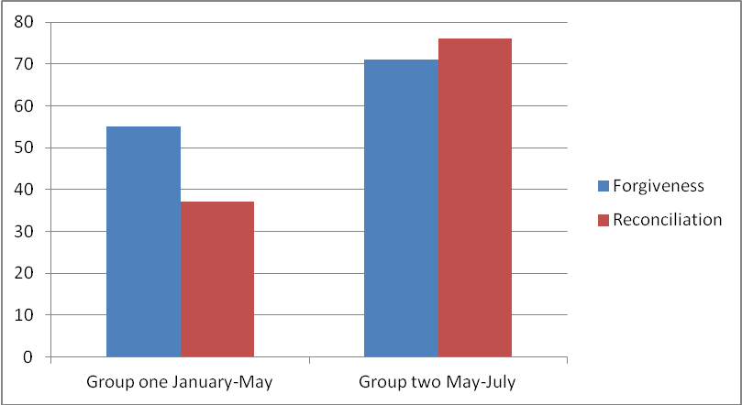

Thus, with the workshops made in two groups, 84,8% from the total of teachers reached the first two phases, forgiveness and reconciliation, and 11.4% finished the forgiveness phase but need to work on Reconciliation. Only 5 people, 3.8% from the total of teachers, have not taken any of the phases (see Graphic 2).
Initially, the Project team had considered that, given the difficulties of working with teachers from the public sector, the fact of reaching 75%-80% would already have an impact on schools. This last opinion was based on previous experiences from the Foundation, and the feeling that in general those express the organizations that promote “external” actions around public schools. However, directives’ support on one side, and on the other the “contagion“ from pioneer teachers to their colleagues, came to the conclusion that more teachers than expected participated in ESPERE. With the achieved coverage until now, the initial expectation is already overcome, and the impact is expected to increase in the next few months even more.
  - Results from the process which are shown on the Network
Three focus groups were composed by female and male teachers who participated in ESPERE schools during the first trimester 2013. As a result from these three focus groups, the contribution of ESPERE to the development of certain socio-emotional skills in teachers could be identified. According to the hypothesis in which the Pilot design has been based on, the development of interpersonal relation skills, communication and skills when managing emotions, can contribute to improve the school classroom environment at schools. In turn, a better environment in classrooms can contribute to the improvement of learning conditions and can be reflected on improvements of the quality of education.
On the other hand, the emphasis of the pilot in terms of socio-emotional skills in teachers is explained through the objective of promoting new ways of being a teacher, from care ethics, forgiveness and reconciliation culture.
As shown in the next testimonies, teachers claim that they have initiated a “life process” and that ESPERE is having effects in their family as well as in their professional life. Below, each one of the identified skills is shown, along with the testimonies of one or more people participating on the focus groups.
- The experience contributes to a new understanding of the conflict on a daily life basis.
- “I could elaborate a new understanding of any kind of conflicts. It is very valuable, because beyond avoiding situations or running away and hiding things, it is a way of a new understanding of what is happening in different parts of my personal and social life with students. “(IED Virrey).
- Contributes to a new positive attitude to prevent conflict:
- “The biggest achievement was to release myself from the aspects I am always carrying. I feel much lighter and with a more receptive attitude and to be able to do more for others without having to support everybody myself. I am still in an internal fight. (IED Tenerife)
- “I liked it, I was very happy and I am still happy” (IED Tenerife).

- Contributes to prevent “violent reactions” facing daily life situations:
- “In the morning everybody is stressed out and they answer back, but the immediate reaction is getting angry, but because of ESPERE I decided not to argue (IED Virrey)”.

- Contributes to learn how to recognize others in work as well as in family places.
- To me it was an invitation to recognize other people and also to be recognized. That makes that we have less differences. (IED El Virrey).
- I have learnt to look at my family in a new light, I listen more carefully, I feel that people listen to me. (IED Tenerife).

- Contributes to a new look towards past affections, what can become a favorable attitude towards forgiveness on a daily basis and with students.
- I see what I’ve been through reflected in a more relaxed and less strong way when I talk to my students.
- Contributes to a new language of care.
- We ended up (from ESPERE experience) with a “look of love”, or the hug or “I forgive you”, these are aspects that generate conversation, new hidden codes” (IED El Virrey).

- Contributes to generate the capacity of empathy from teachers to students.
  - “When we work with difficult populations, where there is confrontation, we tend to dehumanize, and become stronger. But there are children who are not strong enough and also who make you feel sad. ESPERE made me evaluate my principles, if I’m wrong, why the kid can’t be wrong if he’s in a formation process? Those days in ESPERE made me think if they (students) see an example in us (teachers), and they made a mistake, so they feel like not doing it again”.
Other results from the process regarding strengths as well as opportunities and needs:
- There was a unique opportunity to teachers’ meeting from schools and colleagues from other organizations.
- “If teachers try to be friends, every problem that we face in the community would be easier to solve”. (IED El Virrey)
- “It was a very important opportunity to get to know oneself in a different environment. Share the table, the room, the night…..the dynamic is always different, it was important to reinforce relations and change prejudiced ideas that we have from other people. (IED Tenerife)
- We hope team work evolves in a better way, we are a team and we have to support each other, as long as we keep positive, things influence children”. (IED Tenerife)
- Expectations are generated with regards to the impact that ESPERE could have beyond teachers:

- “To make a projection it would be ideal that this formation process, this education, can be taken to school communities. Start with a few teachers and parents. If we achieve changes in families, there will be changes in boys and girls” (IED Tenerife).
- Children are full of resentment because of what they go through with their families, their regrets come from outside, from their history, their parents and grandparents, school is a break from their families, what teachers do is lessen the pain, we can’t solve anything, because they come back to their families” (IED Tenerife)
- Some difficulties and expectations are pointed out with regards to the work of the project:
- “I see the process extremely slow. If it is difficult for adults, it would be much more difficult for students” (IED Tenerife)
- “We tell (who did not go through the experience) but I also felt bad when you know people who are apathetic to these things” (IED Tenerife)
- With ESPERE I have great expectations regarding how I can contribute, not only to the armed conflict, but also through what I do, at home and from school” (IED Virrey)

- They find the purpose of the experience inside a pedagogical program frame:
- The purpose is reparation and healing before insults that we have had, learn to understand situations from another perspective, joint responsibility. A way of healing relations, release problems, regrets”. (IED El Virrey)

  - Analysis and Projections

From the theory of Emotional Education, four possible dimensions are considered so that people develop emotional competence: (i) recognizing their own emotions, (ii) managing their emotions, (iii) recognizing others’ emotions and (iv) relating positively to people.
The schools emphasize that with ESPERE, participants reflect about themselves and start developing a capacity of self observation and self discovery. When people generate for themselves the abilities of self observation, then they can make changes in their practice as teachers but not before.
Teachers start recognizing and accepting the emotional triggers which are associated with past situations that configure ungrateful memories in their lives. Through ESPERE, a clean-up or emotional release process is possible, and people claim feeling more free and lighter. In fact, it is considered that daily provocations do not affect or destabilize them anymore, and they can stop to transcend the reactive or defensive impulse. The testimonies from teachers remind of the elements that are associated to what is known in aboriginal communities as clean-up and that scientific communities have studied and confirmed as the healing power of forgiveness, which from a health care point of view, implies less physical somatized pain.
Simultaneously, ESPERE experience, contributes to develop the capacity of “putting in someone else’s shoes”. “Now I can see everything in a new light” is a repeated expression by teachers, and makes reference to the ability that they are developing to empathize with colleagues or students. Here the empathy refers to the emotional ability that a person has when they can find themselves in others’ frame of reference. Teachers continuously associate the development of this ability to a bigger capacity of preventing the conflicts with colleagues or parents and this way, they contemplate a contribution from their own personal evolution, to the school environment.
From these processes, there is a projection for next semester to implement the “Five Mirrors to Look at Oneself” and discuss in schools. These are tools so that schools analyze their own realities and can make a contrast with the foundations of Care and Reconciliation Pedagogy. By the end of this year (December 2013) with the information resulted from the Mirrors, schools could make a basic proposal of an action plan for 2014.
The Foundation for Reconciliation will be guiding the activity of Looking in the Mirror, with institutional visits in which tools previously defined will be used to promote discussion and joint construction of meanings in the school community.

RECONCILIATION NETWORK (RPR): Online Platform

Taking into account the needs of Care and Reconciliation Pedagogy Pilot, a social network has been developed focused on PCR under the name “Red Para la Reconciliación (Network for Reconciliation), as dialogue and systematization tool that pretends (i) Register users according to a profile (ii) Develop training tools (iii) Facilitate access to supporting documents (audios, videos, pictures, library among others), (iv) Develop collaborative learning, (v) Generate useful reports for researchers.
3.1. Phases and growth: previews on the network January 2013 to June 2013.
The Network has gone through three phases from its creation: 1. Choice stage of technological support, 2. Planning and design stage. 3. Opening and motivation stage. The three stages from the platform started on the 8th of August 2012 and a fourth stage is anticipated for its growth in terms of member and content development: 1. Network opening to focus points; 2. Network opening to “Motivations teams” from each school; 3. Network opening to teachers. 4. Positioning and recognition of the network.

Throughout the report handed out in December 2012 to Goldin Institute, the stages 1 and 2 from Phase 3 were shown. The following report shows previews from Stage 3:
Phase 3-Stage 3: Opening of RPR to teachers from different countries:
On November 30th 2012, the Network was opened to all teachers from the four international schools which participate in the pilot project PCR. The increased number in users bound to in each school has been progressive as see on table 4:
Table 4: International Schools on the Network
School | Invited teachers | Members March-April | Members June
Nuestra Señora de la Consolata | 94 teachers | 29 | 64
Padre Damián | 67 teachers | 50 | 56
Loyola | 53 teachers | 45 | 77
Instituto Mater |  | 33 | 41

The following strategies are highlighted to motivate the network login in international schools during Phase 3:
- Recognize and value the technological needs and limitations of teachers in each school.
- Send personal invitations to teachers on their e-mails.
- Show how the platform works to a group of teachers who are competent in technology, so that they can be tutors to the rest of the teachers.
- Make demonstrations about how the platform works during visits to each schools
- Online guidance throughout the platform Skype.
Network Opening for teachers from Schools at Usme Bogota, who did ESPERE Forgiveness and Reconciliation Phase.
The opening stage of the Network to teachers at Usme who did the Forgiveness Phase ESPERE, started in March 2013, and there has been a progressive development regarding teachers bounding, as seen on table 4:
Table 4: Development of online groups on the network for schools at Usme
School | Definition Focus Point | Creation of the network group | Members June
Virrey Solís Usme | April 17th 2013 | May | 19
Tenerife Granada Sur | April 18th 2013 | June | 16
Rurales Usme Alto | April 22nd 2013 | June | 9

  - Network analysis
In 2013, the Network has been coming to life on its own, being boosted mostly by teachers in different schools, which is a positive evidence of its progress. Besides, the participation of members that the Net generates, are guiding us towards what is meaningful for them, being one of the most important bases for social network mobility.
Today the network has 7 specific tools and 8 tabs or web pages on the main toolbar to achieve the objectives that are proposed on it; a. Groups, b. Forums, c. Blog “Experiences”, d. Videos and Pictures, e. Chats, News Banner, Events, Pages.
To do this analysis, it is necessary to check the use and progress of each one of these tools and tabs.
- Groups
The analysis of the Network development is made from the concepts of one way, bidirectional and multidirectional communication. These concepts are useful because as noted at the beginning of this section, the Network seeks generate exchanges among teachers about their educational experiences to promote a way of educating in peers.
It is understood that one way communication is present when the Network Administration opens a group; new members take part but do not generate participation.
The communication will be bidirectional when Forums inside the groups are created, and each forum has communication between the group administrator and different members of the net.
Finally, the communication will be multidirectional, when there is exchange between participants, from one to another, with or without participation from the Net administrator.
In Stage 2, there was only a one way communication and bidirectional in some cases. (See table 5). Based on what has been analyzed in the process, it was due to three relevant aspects: a. The topic was not of interest for members who at that moment were online; b. There were few members online; c. the group administrator was not competent on social networks and on the creation and stimulations of forums.
The groups that could generate bidirectional communication on stage 2 suggested forums with topics of interest within the Project, and there was a continuous invitation to participate from FpR.
Table 5: Thematic Groups on the Network in Stage 2
Group | Content | Members
Espere | Dialogue and reflection about the experience of ESPERE at school | 56
Care | Dialogue and reflection about how to interpret and live PCR at school | 47
Bolsilibro | Dialogue about Bolsilibro | Closed
Meaning Sense | Dialogue about communication processes | Closed
Activity tree or tool box | Activities to learn and teach about care and reconciliation | 98
Forum Mirrors | Dialogue and reflection about the construction process of the work plan in PCR for 2013 | Open. Does not require membership
Forum Work Plan | Experiences from teachers who try curricular integration | Open. Does not need membership

In Stage 3 there are 15 groups in total, because three additional groups were created for Stage 2: Cultivating Emotions, Watching Films for Emotions, Share to go on and additionally the groups from the schools in Bogota.
During this stage a new level of communication and relation was achieved among members on the Net, who began to talk within the same place. However this level was not completed in all groups, but in some who had certain characteristics: (i) They had to do with daily life experiences, (ii) the topics were related to common problems, (iii) the topics were versatile, entertaining and those required of a knowledge that many people can talk about, advise and suggest without a need having any academic or theoretical background.
- Forums
The net has forums within the groups which are created and additionally has a general forum:
Group Forums: Forum groups have a great reception, since those have to do with the topic for which people have joined the group. This report analyzes specifically the Group ESPERE, the forums which were opened in this group.
General Forum: It has not had great reception. The open forums from the Foundation do not generate great debate, and the forum opened by one of the teachers, had a great reception at the beginning, but has been inactive in the last period.
- Blog Experiences

This blog compiles teachers’ experiences from the 7 institutions in the Pilot of PCR. Simultaneously experience posting has increased and there has also been an exchange around them. By June 30th there were 52 entries which have generated a multilateral communication about 17 experiences among teachers from the five countries that participate in the project PCR. Also, there have been comments from teachers who have taken the experience that they found on the Net and who have started applying it in their schools. Finally this has allowed us to know about the transformations that have been generating in schools, since some posts have included comments and experiences from students and teachers in front of the experiences that were posted.

- VIDEOS AND PICTURES
After analyzing this tool, it has been found that videos are one of the most visited sites by members on the Net, we have videos that have been reproduced 78 times, followed by videos with 50, 40, 28 and 20 reproductions, this clearly shows that the video tool is a great source of knowledge and information, that if used correctly, could contribute directly to the proposed purposes and goals within the Net.
Regarding pictures, it has been found that people use them as a way of including messages and showing some of their activities.
- CHATS
Chats are one of the most used tools by teachers to communicate in a bilateral way with their partners and also have as an advantage to build a sense among members of the net.

- NEWS BANNER, EVENTS AND PAGES:
These three sites have had in general little dynamics, although those are expected to boost the Net and keep participants updated. The analysis and projections suggest some ideas for these sites.

3.3. How to talk on the Net about Forgiveness and Reconciliation? Impact on schools which is visible throughout the Net

The Net opened a group called ESPERE which invites to talk about the many ways that experience ESPERE, is renovating teaching practicum. It is proposed that people join the group, share their experiences, points of view and knowledge, as protagonists of Forgiveness and Reconciliation.

By June 30th this group had 55 members from all international schools and 4 opened forums which are shown on Table 6:
Table 6: Forums about Forgiveness and Reconciliation in group ESPERE
Name of Forum | Topic of Forum | Opening date
The meaning of ESPERE schools | The meaning of ESPERE schools in people’s lives | October 2nd, 2012
… and then the father stood up and got out slamming the door….. | How does a teacher who experienced ESPERE react to a conflict with an angry parent? | November 29th, 2012
Is Ghandi right? | Discuss about the statement: “first personal change and then social change” | January 28th 2013
A new attitude to teach | Revise the experience from the teacher practicum point of view. | February 4th, 2013

The dialogues on the net, illustrate the way in which people in schools, who have experienced ESPERE, are in a process that can increase their ability to forgive and to love. In general, there is a process in which teachers accept self observation to understand their own motivations and contradictions. And from there, start a journey of personal evolution. It is suggested by participants the need of having a guidance from colleagues who have participated in ESPERE to support each other mutually on daily life attitudes. It is recognized by them the need of being in a permanent “exercise”.
Oscar Juan Villareal Solís (MX) December 5th, 2012 at 11:59 am.
“These are things that they have to practice constantly, how I communicate hard decisions, managing emotions, and recognizing that the reaction of others can or cannot be personal, it has to do a lot with the ability to know how I feel, why I feel that way and what has to do with me and what has to do with others”.
The four open forums, have given several ways of exchange, in some cases, from the Foundation, questions are generated which people answer in the bidirectional way that was explained in the last section. In other cases, there are exchanges among all participants, commenting each other their thoughts and experiences. In each one of the forums, teachers participated in Argentina, Peru, Mexico, Colombia and Dominican Republic.
The analysis from the interventions on the Net along the four open forums, allows observing a series of learning processes in the ability of self observation and relations with others. Subsequently, these learning processes are identified and each item from the list is illustrated as a testimony that was selected from the dialogues on the Net, naming the participant as well as the date of their intervention.
- Ability of self-observation
MARIA RAQUEL NÁVAR RODRÍGUEZ MX December 6th, 2012 at 10:23 a.m
“I think ESPERE are a tool that work as a “hinge” between my inside and my outside, meaning, between what I feel, how I see it, how I am going to express it and if in this moment the exercise of Forgiveness is “How”, I think we can be our own personal entertainer.
In any case, I think that if people do not have a previous and constant practice when managing emotions, communication (in various levels and styles), they will probably act impulsively (in the case of the father) and feel frustration or guilt (in the case of the teacher), even when both had worked on ESPERE. When people know how to manage their emotions and communication, it would be easier to identify what is happening and as a consequence
To know how to be our own personal trainers, could be, making use of self-observation in the first place, to realize what is happening to me and how I feel, with the situation I’m going through and checking how I express myself and whether it is difficult to modify them or not.
MIRIAN ARANZAMENDI FERNANDEZ October 19th, 2012 at 9:17 a.m
I could know and recognize some aspects I did not know about myself and heal wounds that I had forgotten.
- Ability to relate from the Empathy
J. RICARDO SÁNCHEZ, February 6th, 2013 at 2:19 p.m
The workshop (ESPERE) contributes to a series of elements that are composed on one side by a pedagogical proposal, and on the other, in didactics when figuring out or understanding in a better way who is the other person who coexists with me.
LUZ ANGELA MURCIA SEGURA February 28th, 2013 at 6:10 p.m
Hi everyone! When you attend the workshop of ESPERE, this gives you tools for your personal, work and social life. These tools create a change in your thoughts and conscience regarding to putting on someone else’s shoes, creating a language, strategies to be more understanding in every aspect of life.
MÓNICA REGINA GANEM November 30th, 2012 at 9:16 a.m
I think that the reaction of a person who experienced ESPERE is different, you learn to put yourself on someone else’s shoes, that father, feels hurt, his son is in the middle, and he is not being very objective. He probably acts impulsively because he feels anger, sadness, etc. and he can’t rationalize it. The teacher would have to try not to feel this situation as something personal, and find ways to make that father understand why the decision of the school, once he’s calm. Find by all means the dialogue, until having an agreement.
- Consider love pedagogy more effective that the use of authority from the teacher:
LUIS SOTO: February 25th, 2013 at 10:10 p.m
My experience makes me remember a phrase that my teacher used when I was a kid “everything by means of love, not by means of violence”. I never thought years after I would also be a teacher, now I put this beautiful phrase in practice, in my job, I love that my students consider me as a teacher and friend.
- Learn how to pause calmly which stops violent reactions from an impulse or trigger.
Alicia Isabel Lourdes Rodríguez December 9th, 2012 at 6:06 p.m
Throughout the tools you get from ESPERE, you can realize or make that moment of silence and try to start over a conversation and that the father can listen without getting angry again. We have the tools, we might not be conscious that we have not used them and through ESPERE you can visualize what you are achieving.
  - Analysis and Projections
The Net as a tool to benefit dialogue and exchange of experiences is demonstrating its usefulness in the frame of PCR. On a first level, participants express themselves about the process of change that they see. As shown, when talking about the hypothesis in which PCR is based on, this is a key element of the proposal intervention design in the school. When opening to share this inner experience, people set down the way in which they interpret their inner experiences, and how those experiences are having an impact on their relations to others.
On a second level, when the expression that a teacher does regarding their own process, they find on the Net an “Other” who starts a dialogue from there, a new understanding is given in that person and their interlocutor, about the scope of what they are going through. Meaning, the teacher who for example has experienced ESPERE, shows on the net what they feel and experiment in their internal dimension, and express it in words to other teachers in another school. Although this is a unique and personal experience, it echoes on the “other” and might encourage the other person to share their own reality. From that moment, beyond an online conversation- as in any other social network such as Facebook- what we see is a new understanding of a process scope that is having an impact on interpersonal relations, from a new perspective that ESPERE provided.
On a third level, the Net is calling teachers to offer other colleagues their personal interpretation of the experience from the rehearsal with their students, activities that put in practice the principles of PCR. This exercise of “offering”, is putting in action a process to figure out the key to school coexistence. The levels of exchange allow the interpretation that a teacher makes, come into play with another teacher’s interpretation, without invalidating any of the interpretations by being correct or incorrect. The dialogue simply opens multiple possibilities.

There is a rule within the social networks called 1-9-90: 1 per cent of the population creates the content, 9% comments or participates and 90% only sufs on the net. On our Network from 295 members: 16 of them generate content, meaning 5.4%. From 295 members, 65 participated in some way on the Net, meaning 22%, 73 % from the members surf on the Net or do not login. The previous shows that our social Network has high rates of content and participation generation.

At this moment the Pilot Social Network is being useful not only to find didactic resources such as videos, or to establish casual contact with teachers from other countries, but above all, to reassign among participants, a new dimension of educational quality. Even though the topic “educational quality” has not been subject of a group or a specific forum on the Net, the emergent dialogues show the new visions that are generating from the practice such as kind greetings, the shared reflection of texts, and the integration of teachers in recreational kinesthetic activities, among others.
From this point of view, the Net projects itself to a new stage in the last semester which will be characterized by generating new dialogues from questions or forums that demand a greater level of compromise with the introspection and projection exercise towards institutionalism. This will occur maximizing the strategy of dialogues, with the revision of the effectiveness of the groups, and with incentives to promote inter-school work pointing to systematize project learning.

Female teacher, School Virrey Solis. Focus Group. Usme May 2013
Reconciliation Foundation 2011. Notes about care and reconciliation
DILE is the official organization in charge of guiding and regulating the educational offerings in the Locality of Usme
Meertens, Donny. “Genre, displacement and rights” (Online) Available at: http//www.piupc.unal.edu.co/catedra01pdfs/DonnyMeertens.pdf accessed: January 20th 2010.
Graves and Bradberry, Emotional Intelligence 2.0 In the first trimester 2013, a team from the Foundation of Reconciliation visited each international school during 4 or 5 days. During this visit a formation and socio-emotional workshop was made for teachers and they were trained for the Network handling.

